How to backup data from we not avable to access instance to another instance,

Step 1: Stop Your EC2 Instance (Without Terminating It)
- Go to the EC2 Dashboard:
  - In the AWS Management Console, navigate to the EC2 Dashboard.
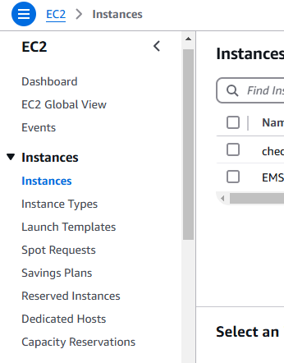

- Find Your EC2 Instance:
  - Locate the instance that you cannot log into. Make sure the instance is running before you proceed.
- Stop the Instance:
  - Select the instance, then click on Instance State > Stop.
  - Important: Do not terminate the instance, as terminating it will permanently delete the instance and its data.

Step 2: Detach the Root EBS Volume from the Inaccessible Instance
- Navigate to the Volumes Section:
  - In the EC2 Dashboard, under Elastic Block Store (EBS), go to Volumes.
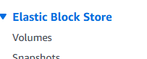

- Identify the Root Volume:
  - Look for the volume attached to your problematic instance. It will typically be named /dev/xvda (for Ubuntu). If it's a secondary volume, it might be something like /dev/sdf.
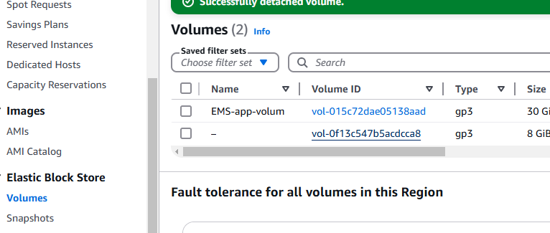

- Detach the Volume:
  - Select the volume and click Actions > Detach Volume.
  - Wait for the volume to be detached successfully.
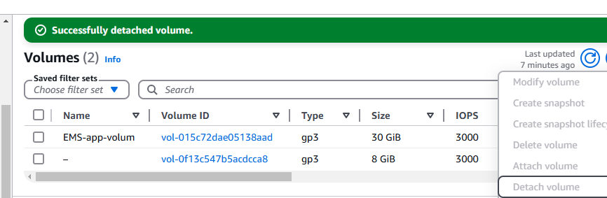

Step 3: Attach the Volume to a Running EC2 Instance
- Find a Running EC2 Instance:
  - You need a running EC2 instance that you have SSH access to. This could be any instance in your account that is functioning properly.
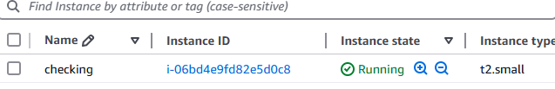

- Attach the Detached Volume:
  - In the Volumes section, select the detached volume and click Actions > Attach Volume.
  - Attach the volume to the running instance. Choose a device name, e.g., /dev/xvdf or /dev/sdf.

Confirm Volume Status (Available/Detached)
- Go to the EC2 Console:
  - In the AWS Management Console, navigate to EC2 Dashboard.
- Check the Volume Status:
  - In the Elastic Block Store (EBS) section on the left-hand menu, click Volumes.
  - Locate the volume with the ID vol-0f13c547b5acdcca8 (or the volume you're trying to attach).
  - Check the status of the volume. You should see one of these statuses:
    - In-use: The volume is already attached to an instance.
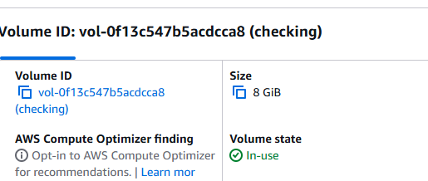

    - Available: The volume is not attached and can be attached to a running instance.
If the volume is In-use, it is already attached to an instance and cannot be reattached. You'll need to first detach it from the existing instance.
If the volume is Available, you should be able to attach it to another running instance.

Step 4: SSH into the Running EC2 Instance
- SSH into the Running Instance:
  - Use SSH to connect to the instance where you attached the volume.
  - The command to SSH into your running instance is:
bash
Copy
ssh -i /path/to/your-key.pem ubuntu@<running-instance-public-ip>
  - Replace /path/to/your-key.pem with the path to your private key file and <running-instance-public-ip> with the public IP of the running EC2 instance.

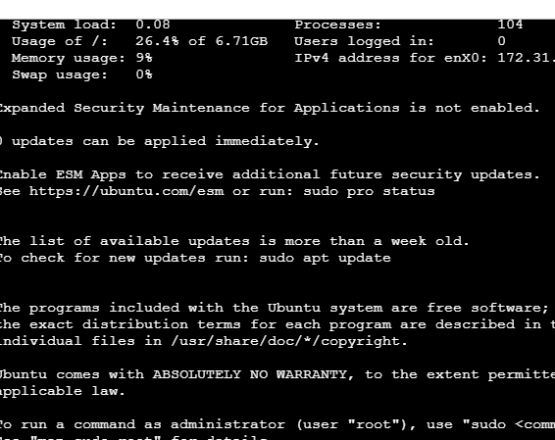

Step 5: Mount the Detached Volume
- Check Available Disks:
  - Run the following command to check the attached disks:
bash
Copy
sudo fdisk -l

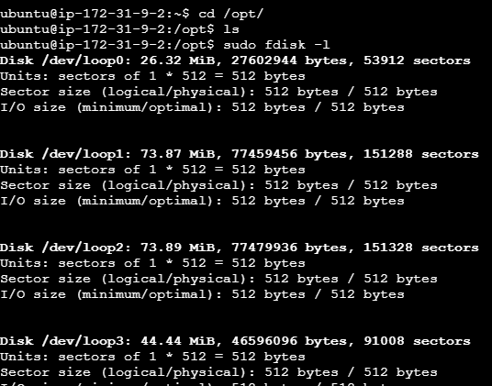

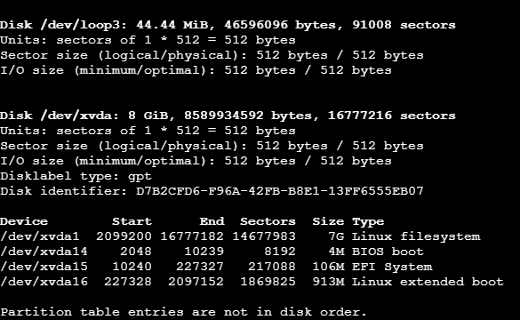

  - This will list all the disks. The attached volume should be listed as /dev/xvdf (or /dev/sdf, depending on the name).
- Create a Mount Point:
  - Create a directory where the volume will be mounted:
bash
Copy
sudo mkdir /mnt/data

- Mount the Volume:
  - Mount the volume to the created directory. If the volume is /dev/xvdf, you can use:
bash
Copy
sudo mount /dev/xvdf1 /mnt/data
  - Note: If it's a different device, replace /dev/xvdf1 with the correct device name.

========================
=================================
=========================================

Sure! Here’s a step-by-step guide to retrieve data from an inaccessible EC2 instance running Ubuntu. The process involves detaching the EBS volume from your original instance and mounting it on another accessible EC2 instance to recover your data.

Step-by-Step Guide to Retrieve Data from an Inaccessible EC2 Instance

Step 1: Stop Your EC2 Instance (Without Terminating It)
- Go to the EC2 Dashboard:
  - In the AWS Management Console, navigate to the EC2 Dashboard.
- Find Your EC2 Instance:
  - Locate the instance that you cannot log into. Make sure the instance is running before you proceed.
- Stop the Instance:
  - Select the instance, then click on Instance State > Stop.
  - Important: Do not terminate the instance, as terminating it will permanently delete the instance and its data.

Step 2: Detach the Root EBS Volume from the Inaccessible Instance
- Navigate to the Volumes Section:
  - In the EC2 Dashboard, under Elastic Block Store (EBS), go to Volumes.
- Identify the Root Volume:
  - Look for the volume attached to your problematic instance. It will typically be named /dev/xvda (for Ubuntu). If it's a secondary volume, it might be something like /dev/sdf.
- Detach the Volume:
  - Select the volume and click Actions > Detach Volume.
  - Wait for the volume to be detached successfully.

Step 3: Attach the Volume to a Running EC2 Instance
- Find a Running EC2 Instance:
  - You need a running EC2 instance that you have SSH access to. This could be any instance in your account that is functioning properly.
- Attach the Detached Volume:
  - In the Volumes section, select the detached volume and click Actions > Attach Volume.
  - Attach the volume to the running instance. Choose a device name, e.g., /dev/xvdf or /dev/sdf.

Step 4: SSH into the Running EC2 Instance
- SSH into the Running Instance:
  - Use SSH to connect to the instance where you attached the volume.
  - The command to SSH into your running instance is:
bash
Copy
ssh -i /path/to/your-key.pem ubuntu@<running-instance-public-ip>
  - Replace /path/to/your-key.pem with the path to your private key file and <running-instance-public-ip> with the public IP of the running EC2 instance.

Step 5: Mount the Detached Volume
- Check Available Disks:
  - Run the following command to check the attached disks:
bash
Copy
sudo fdisk -l
  - This will list all the disks. The attached volume should be listed as /dev/xvdf (or /dev/sdf, depending on the name).
- Create a Mount Point:
  - Create a directory where the volume will be mounted:
bash
Copy
sudo mkdir /mnt/data
- Mount the Volume:
  - Mount the volume to the created directory. If the volume is /dev/xvdf, you can use:
bash
Copy
sudo mount /dev/xvdf1 /mnt/data
  - Note: If it's a different device, replace /dev/xvdf1 with the correct device name.

Step 6: Access Your Data
- Navigate to the Mounted Directory:
  - After mounting, go to /mnt/data to access the files from your original instance:
bash
Copy
cd /mnt/data
ls
- Copy Files to the Running Instance:
  - You can copy your files to the running EC2 instance or use SCP to download them to your local machine:
bash
Copy
scp -i /path/to/your-key.pem ubuntu@<running-instance-ip>:/mnt/data/<file-to-download> /local/path
  - Replace /local/path with the destination directory on your local machine.

Step 7: Unmount the Volume (Optional)
- Unmount the Volume:
  - Once you have finished retrieving the data, you can unmount the volume:
bash
Copy
sudo umount /mnt/data

Step 8: Reattach the Volume to the Original Instance (if Needed)
- Reattach to Original Instance:
  - After you've retrieved your data, you can reattach the volume back to the original EC2 instance.
  - In the Volumes section, select the volume and click Actions > Attach Volume.
  - Attach it back to the original instance.

Additional Tips
- Lost SSH Key Pair:
  - If you are unable to log into the original instance due to a lost key pair, you can reset the SSH key by mounting the volume to another EC2 instance and modifying the ~/.ssh/authorized_keys file to add a new key.
- Check System Logs:
  - If you're unsure why the instance is inaccessible, you can check the system logs from the EC2 dashboard by going to Actions > Get System Log.

Summary
- Stop your EC2 instance (don't terminate it).
- Detach the root EBS volume.
- Attach the volume to another accessible EC2 instance.
- SSH into the new instance, mount the volume, and access your data.
- Optionally, unmount the volume and reattach it to the original instance if needed.
Let me know if you encounter any issues or need further help!

